Monthly Performance Report – March 2025
Kestrel Ridge Wind Farm (75.6 MW)
David Chen · 09 April 2025 · KR-OPS-RPT-2025-03

1. Summary
Kestrel Ridge generated 20.4 GWh in March 2025, 6.0 % below the P50 budget of 21.7 GWh. Time-based availability was strong at 97.6 % (contract target 97.0 %). The wind resource was weak: 8.7 m/s against a long-term monthly mean of 9.0 m/s.

2. Production and key figures
KPI | March 2025 | Budget / target | YTD 2025 | YTD budget
Net generation (GWh) | 20.4 | 21.7 | 64.3 | 68.1
Time-based availability | 97.6 % | 97.0 % | 97.2 % | 97.0 %
Capacity factor | 36.3 % | 38.6 % | 39.4 % | –
Mean wind speed at hub height (m/s) | 8.7 | 9.0 | – | –
Source: Kestrel Ridge SCADA, revenue meter at 132 kV point of connection. Budget = P50 (2024 post-construction yield assessment).
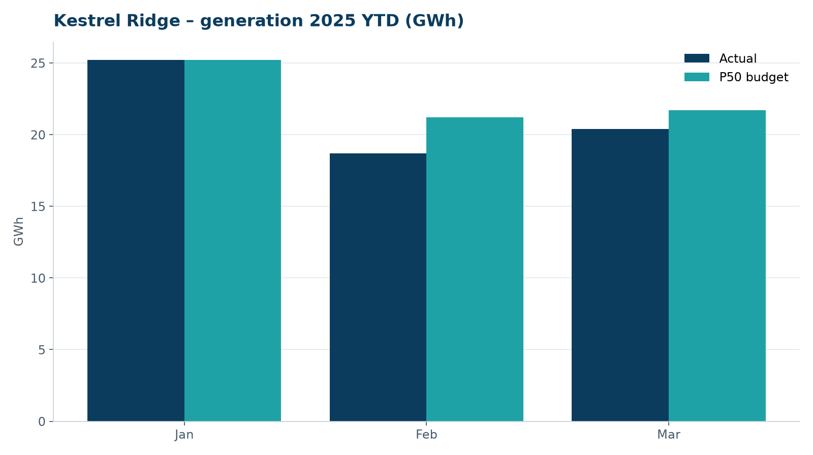
Monthly generation vs. P50 budget, 2025 year to date

3. Availability and downtime
Total turbine downtime attributable to the contractor amounted to 83 turbine-hours for the top events listed below. No grid or force majeure exclusions were claimed this month.
Turbine | Event | Downtime (h)
T-11 | converter fault – IGBT module replaced | 39
T-18 | yaw brake pad wear – pads replaced | 20
T-18 | service lift fault – lift locked out, turbine stopped for rescue cover | 10
T-05 | high-voltage transformer gas relay alarm (inspected, no fault found) | 10
T-14 | tower base controller communication loss | 4
Top downtime events of the month (SCADA event log, reviewed with Highline Wind Services).

4. Maintenance
- 22 corrective work orders closed, 2 still open at month end.
- Substation monthly inspection completed; no abnormalities on the 33/132 kV transformer.

5. Health, safety and environment
Indicator | Month
Hours worked on site (Highline + Weyland) | 2,589
Lost time injuries | 0
First aid cases | 0
Near misses reported | 2
Safety observations | 8
Environmental incidents | 0

No complaints from neighbours were received this month.

6. Outlook
Next month's focus: closing open corrective work orders and preparing the quarterly O&M review with Highline Wind Services.
Prepared by Sara Lindgren (Performance Analyst); reviewed by Ben Okoye (Site Manager) and David Chen (Asset Operations Manager).

